Assignment - 1

TOPIC : SMART HOME

|  |  |
| --- | --- |
| Assignment Date | 7 OCTOBER 2022 |
| Student Name | AKSHAYA K |
| Student Roll Number | 411719205005 |
| Maximum Marks | 2 Marks |

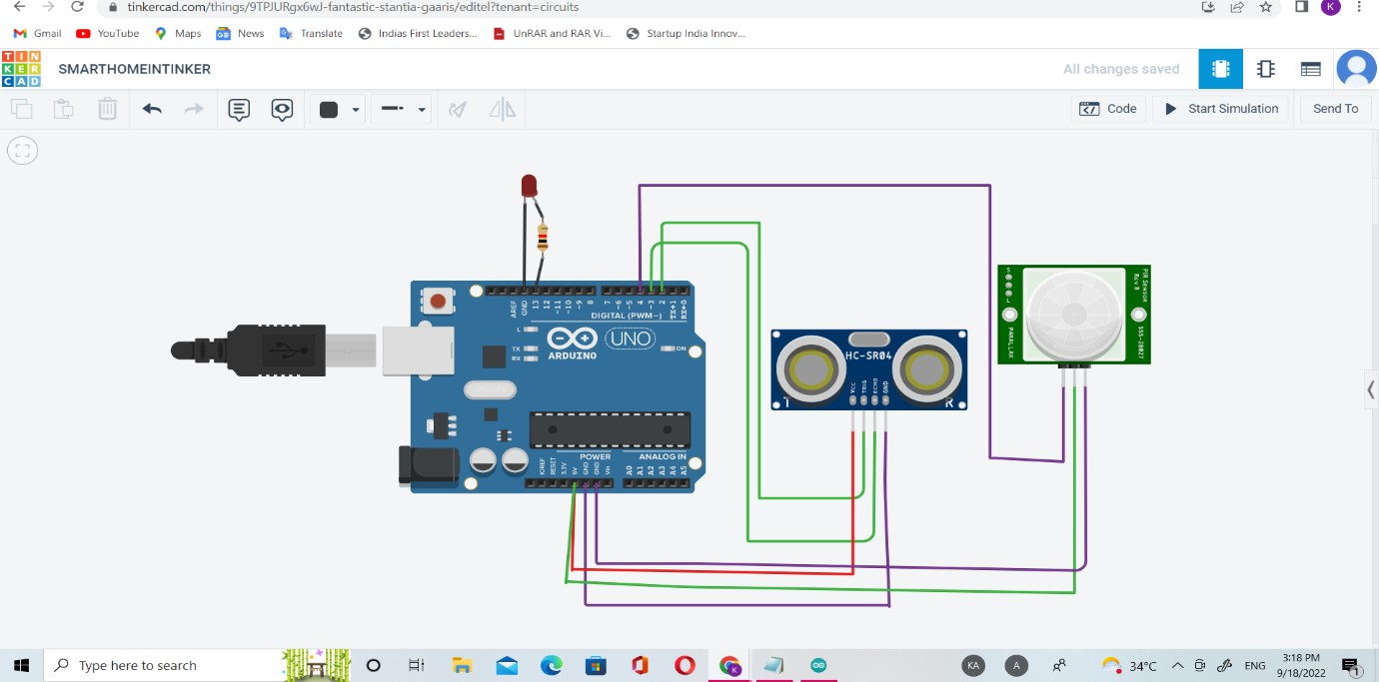

TINKER CAD

CODE:

int trigger_pin=2; int echo_pin=3; int time; int distance; void setup()

{

Serial.begin(9600); pinMode(trigger_pin,OUTPUT); pinMode(echo_pin,INPUT); pinMode(4,INPUT); pinMode(13,OUTPUT);

} void loop()

{

digitalWrite(trigger_pin,HIGH); delayMicroseconds(10); digitalWrite(trigger_pin,LOW); time=pulseIn(echo_pin,HIGH); distance=(time*0.034)/2; if(distance<=10)

{

Serial.println("Door open");

Serial.print("Distance="); Serial.println(distance); delay(500);

} else{

Serial.println("Door closed");

Serial.print("Distance="); Serial.println(distance); delay(500); int p=digitalRead(4);

if(p) { digitalWrite(13,HIGH); Serial.println("motion detected");

} else

{

digitalWrite(13,LOW); Serial.println("not detected");

}

}

}